

The National Association of
Telecommunications Officers and Advisors®

1595 Spring Hill Rd, Suite 330
Vienna, Virginia 22182
(703) 506-3275
(703) 506-3266 Fax
www.natoa.org

SCAN NATOA c/o City TV
525 Broadway
Suite 100
Santa Monica, CA 90401
(909) 387-5967
(909) 387-9613

August 16, 2002

VIA FACSIMILE AND FEDERAL EXPRESS

Carolyn S. Schwartz, U.S. Trustee
Office of the United States Trustee
33 Whitehall Street
21st Floor
New York, NY 10004

Re: Adelphia Communications Corporation, et al. (“Debtors”)
Case No. 02-41729 (REG) Jointly Administered

Dear Ms. Schwartz:
The undersigned, through the network of The National Association of Telecommunications Officers & Advisors (“NATOA”), represent the interest of various municipal and local government agencies and/or authorities (“Local Agencies”), which have franchisor/franchisee relationships with the Debtors.
Pursuant to 11 U.S.C. § 1102(a)(1) we hereby respectfully request that you appoint an official committee of Local Agencies through the ranks of our organization. In a case with more than 190 Debtors and multiple businesses, the appointment of such a committee is necessary to insure that the unique interests of the Local Agencies are adequately represented. As you know, on July 11, 2002, you appointed the Official Committee in the above-captioned matter. The Official Committee is comprised of eleven members. Six members appear to be financial management firms, which manage substantial mutual funds, two members appear to be trustees under trust indentures, and three members appear to be suppliers of programming to Debtors. The lack of any appropriate representation of the interests of Local Agencies in the bankruptcy case leaves the Local Agencies without adequate recourse. The uniform treatment of numerous constituencies in these “mega cases” is fundamentally unfair and inconsistent with overriding policies of the bankruptcy process.
The Local Agencies have interests at stake, which are not common to all creditors of the Debtors. The United States Congress has specifically recognized the unique role of Local Agencies as franchising authorities in the regulation of cable television. Because of the extensive use of the public rights-of-way by the cable operator and the Local Agencies’ substantial interests in controlling the use and maintenance of their public rights-of-way, the Telecommunication Act of 1996 provides exclusive control to Local Agencies. Pursuant to 47 U.S.C. §541(b)(1), cable operators are prohibited from providing cable services without a franchise from Local Agencies. Further §541(a)(4) provides that in awarding a franchise, Local Agencies may require adequate assurance that the cable operator will provide adequate public, educational and governmental access channel capacity, facilities, or financial support; and may require adequate assurance that the cable operator has the financial, technical, or legal qualifications to provide cable service. These matters are of extreme importance to Local Agencies and differ substantially from matters that concern members of the current Official Committee who are creditors of the Debtors as a result of their business dealings with the Debtors.
While Local Agencies have billions of dollars at stake in this bankruptcy, they also have a fiduciary obligation to regulate and manage their rights-of-way in the best interest of the public including, but not limited to safeguarding the public health, safety and welfare. Local Agencies also rely on cable operators for public, educational and government access channels as a primary means of communications with their citizenry. Local schools depend on educational programming and funding by cable operators to support such programming. Local Agencies carry emergency information including the alerts from the emergency broadcast system and local emergency announcements on cable networks. These interests are clear and distinct from monetary interests of creditors and investors in these bankruptcy proceedings.
More importantly, Local Agencies will ultimately have the greatest impact of any single entity on sustaining the ultimate value of Debtors’ most important and core assets. The Local Agencies are the only entities statutorily vested and qualified to determine whether any proposed purchaser is legally, technically, financially and otherwise qualified to assume the obligation of the franchise and to use the public rights-of-way to operate the cable system in the manner identified by Local Agencies to adequately safeguard the local pubic interest. In short, Local Agencies will be instrumental in assuring that a cogent and workable plan of reorganization is drafted and implemented for the benefit of all creditors. Local Agencies through their official committee are eager to bring to the process their expertise, statutory authority and good will.
We recognize that a decision to appoint additional committees is generally made on a case-by-case basis. Consideration, such as the ability of the existing Official Committee to function, the nature of the case, and the standing and desires of the various constituencies assume significance. In re McLean Industries, Inc., 7 Bankr. 852, 860 (Bankr. S.D.N.Y. 1987).
In jointly administered cases such as this, where there are more than 190 separate debtors, a strong inference arises that additional committees may well be appropriate. At least one case has held that such appointment is required as a matter of law. In re White Motor Credit Corp., 18 Bankr. 720 (Bankr. N.D. Ohio 1980). Although this view has not been adopted in the Southern District of New York, several judges have suggested that a multi-debtor, multi-business case, such as this, may be the appropriate set of circumstances to appoint additional committees. In re McLean Industries, Inc., at 863 (Buschman J.) In re Hills Stores, 137 Bankr. 4, 7-8 (Bankr. S.D.N.Y. 1992) (Brozman, Jr.).
Although it is true that conflicting interests are common in any reorganization case, circumstances here make it impossible for even the most diligent committee to adequately represent the interests of the Local Agencies. For example, business creditors have their focus on recovering proceeds of sales, whereas Local Agencies have their focus on the success of the sale and the ability of the purchaser to deal with the public health and safety, public education and emergency broadcast system concerns throughout the country. Judge Brozman in Hills Stores envisioned the situation where creditors of separate debtors had vastly conflicting aims and entitlements and had shown themselves unable to function on a committee such that the appointment of an additional committee may be appropriate. Hills Stores at 7-8. At a minimum, an evidentiary hearing may be required. In McLean Industries, Inc. at 31.
Another factor the courts consider is the timeliness of the request for an additional committee. Here the Local Agencies are making the request within the first 120 days of the case. No plan has been proposed and, in fact, it is the plan process in which Local Agencies wish to participate. Local Agencies' participation will prove to be invaluable for the ultimate successful reorganization of the Debtors.
We believe the appointment of a separate Local Agencies Committee is appropriate to insure adequate representation of these Local Agencies. The fierce litigation tainting the plan confirmation process in the PG&E case pending in the Northern District of California can be correlated to the lack of government input and the absence of a governmental committee. No such costly outcome is the desire of the Local Agencies.
We will be pleased to provide any additional information you require and will meet with you at your convenience. Please contact, Libby Beaty who will coordinate our communications.
Very truly yours,
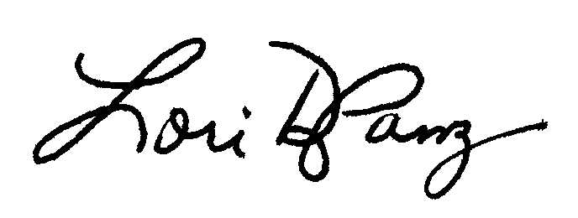

Lori Panzino
President, SCAN NATOA

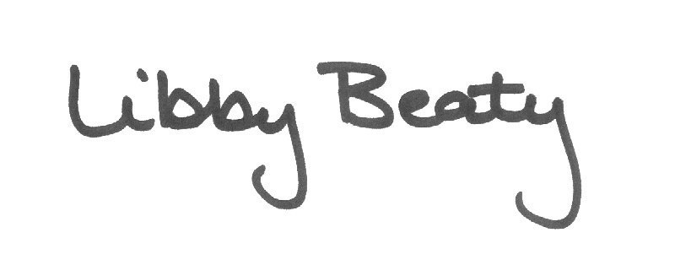

Libby Beaty
Executive Director, NATOA

cc: Board of Directors

